2025 L2 PT Reading Booklet Answer Key

Answer Key week 1

Diagnostic Test
1. B
2.C
3. D
4. A
5. C
6. A
7. B (you only renew books online with the library is closed).
8. B
9. B
10. C
11. A
12. C
13. D
14. B
15. C

Answer key week 2
Examples:
The UK banned indoor smoking to protect health and reduce second-hand smoke.
Paris felt like a dream—beautiful sights, elegant people, and unforgettable adventure.
- high returns (a large amount of money you get when you are paid more for something than it cost you to make, get, or do it.
- inflation (the rate of increase in prices over a given period of time)
- financial independence & security (having enough money to stop working and not depend on anyone else to support you)
- volatility (a state of being likely to change suddenly, especially by becoming worse)
- hackers (people who break into a computer system)
- currency devaluation (the decrease in the value of a country’s money)
- value (how much something is worth, either in terms of cash or importance)
- regulatory environment (people/organisations appointed by government to control an industry such as banking)
- accessibility (the quality of being easy to approach, reach, enter, speak with, use or understand)
- substantial profits (how much money is earned relative to the amount of money spent on an investment)

iii)

Answer key week 3
Topic Sentences in order

  - Have you ever wondered whether keeping up with the latest fashion trends is worth it?
  - Firstly, following fashion trends can make you feel confident.
  - Another advantage is the chance to express your personality.
  - However, there are also some disadvantages to consider.
  - Another downside is the pressure to always look perfect.
  - In addition, trends can change quickly, making it hard to keep up.
  - Furthermore, it is important to consider the environmental costs of the fashion industry
  - In conclusion, keeping up with the latest fashion trends has both advantages and disadvantages.

- Not necessary: Fashion is absolutely essential for everyone all around the world.
Quest Plot Diagram
- Peaceful land, people happy and content.
- Ancient curse unleashed. Crops died, rivers dried, fog covered villages.
- Elara (elf), Thrain (dwarf), Mira (thief) and Lyra (sorceress) went to find the crystal of light.
- Peaks of Mount Tharok (ice trolls, avalanches), Whispering Woods (enchanted creatures), Forgotten Caves (dragon)
- Defeated the dragon, got the Crystal of Light
- Cast the spell to shatter the curse. The land blossomed, the rovers flowed, the fog lifted and the heroes were celebrated).

Answer Key Week 4
- Skimming is reading quickly to get the general idea or gist of a text.
- Scanning is reading quickly to find specific information, like names, dates, or numbers.
- Close reading is reading carefully and in detail to understand deeper meaning, structure, and language.

Comprehension Questions
1. Digital literacy is the ability to use digital tools and technologies effectively.
2. A nurse might use digital tools to track patient records.
3. Critical thinking and problem-solving skills are important because automation is taking over many routine tasks.
4. An example is an engineer working on renewable energy solutions.
5. Emotional intelligence is the ability to understand and manage your own emotions and those of others.
6. Emotional intelligence can improve a workplace environment by enhancing teamwork, communication, and conflict resolution.
7. Adaptability is important because the nature of work is constantly changing, with new jobs emerging.
8. An example is a teacher who shifted from in-person classes to online teaching during the COVID-19 pandemic.
9. Collaboration involves working effectively with others to achieve common goals.
10. In software development, collaboration is used when programmers, designers, and testers work together to create a new application.

Answer key week 5
Here are the text features for each type:
a) Newspaper Article
- Headline – grabs attention and summarizes the main idea
- Byline – includes the author's name and sometimes the date
- Lead paragraph – summarizes the key points (who, what, where, when, why, how)
- Body paragraphs – provide detailed information in order of importance
- Quotes – statements from people involved or experts
- Photographs or images – support the story visually
- Captions – describe the images or photos
- Subheadings – divide the text into sections
- Columns – article often arranged in narrow vertical sections
- Date and publication name – shows when and where it was published

b) Website
- Homepage – main entry point of the website
- Navigation bar/menus – help users move through different pages
- Hyperlinks – clickable text or images that lead to other content
- Headings and subheadings – organize content clearly
- Search bar – allows users to find specific content quickly
- Multimedia elements – videos, audio clips, and interactive features
- Images and graphics – enhance the visual appeal and understanding
- Text boxes or sidebars – highlight important or additional information
- Contact information – email, address, or forms for user interaction
- Footer – contains copyright info, privacy policy, and additional links

Answer key week 6
1. Acronyms
- What it is:
An acronym is a word formed from the first letters of a phrase or group of words.
- Example in a text:
"The NHS provides free healthcare services across the UK."
(NHS = National Health Service)

2. Subheadings
- What it is:
Subheadings are smaller titles that divide a text into sections and show what each part is about.
- Example in a text:
Benefits of Exercise
"Regular exercise improves heart health and boosts energy levels."

3. Captions
- What it is:
A caption is a short piece of text under an image or photo that explains what it shows.
- Example in a text:
"Volunteers planting trees in the local park."
(Caption under a photo in a news article.)

4. Imperatives
- What it is:
Imperatives are command words used to tell someone to do something.
- Example in a text:
"Wash your hands before eating."
(Used in a health poster.)

5. Bullet Points
- What it is:
Bullet points are symbols used to list items or ideas clearly and neatly.
- Example in a text:
To apply, you need:
  - A completed application form
  - Proof of address
  - A recent photo
Week 6 Idioms
a) Piece of cake Something very easy to do
b) Bite the bullet To face a difficult situation bravely
c) The ball is in your court It is up to you to make the next decision or take action
d) Break the ice To initiate conversation in a social setting
e) A penny for your thoughts Asking someone what they are thinking
f) The last straw The final problem in a series that makes a situation unbearable
g) Cost an arm and a leg To be very expensive
h) Let the cat out of the bag To reveal a secret
i) Hit the nail on the head To describe exactly what is causing a situation or problem
j) Barking up the wrong tree Pursuing a mistaken or misguided line of thought or action
k) Burn the midnight oil To work late into the night
l) Cut corners To do something in the easiest, quickest or cheapest way, compromising quality

Answer Key Week 7
Answers

1. **Descriptive Paragraph**
- The main focus is the picturesque village of Lucerne.
- The author describes the charming wooden facades, colourful flowers, a crystal-clear stream and the morning mist to create a vivid image.

2. **Expository Paragraph**
- The process being explained is photosynthesis.
- It is important because it produces the oxygen necessary for most living organisms to breathe.

3. **Persuasive Paragraph**
- The author's main argument is that wearing seat belts should be mandatory.
- The author supports the argument by stating that seat belts save lives, reduce the risk of injury and prevent passengers from being thrown out of vehicles.

4. **Narrative Paragraph**
- The setting is the Amazon rainforest.
- The author describes feeling thrilled and a little scared during the adventure.

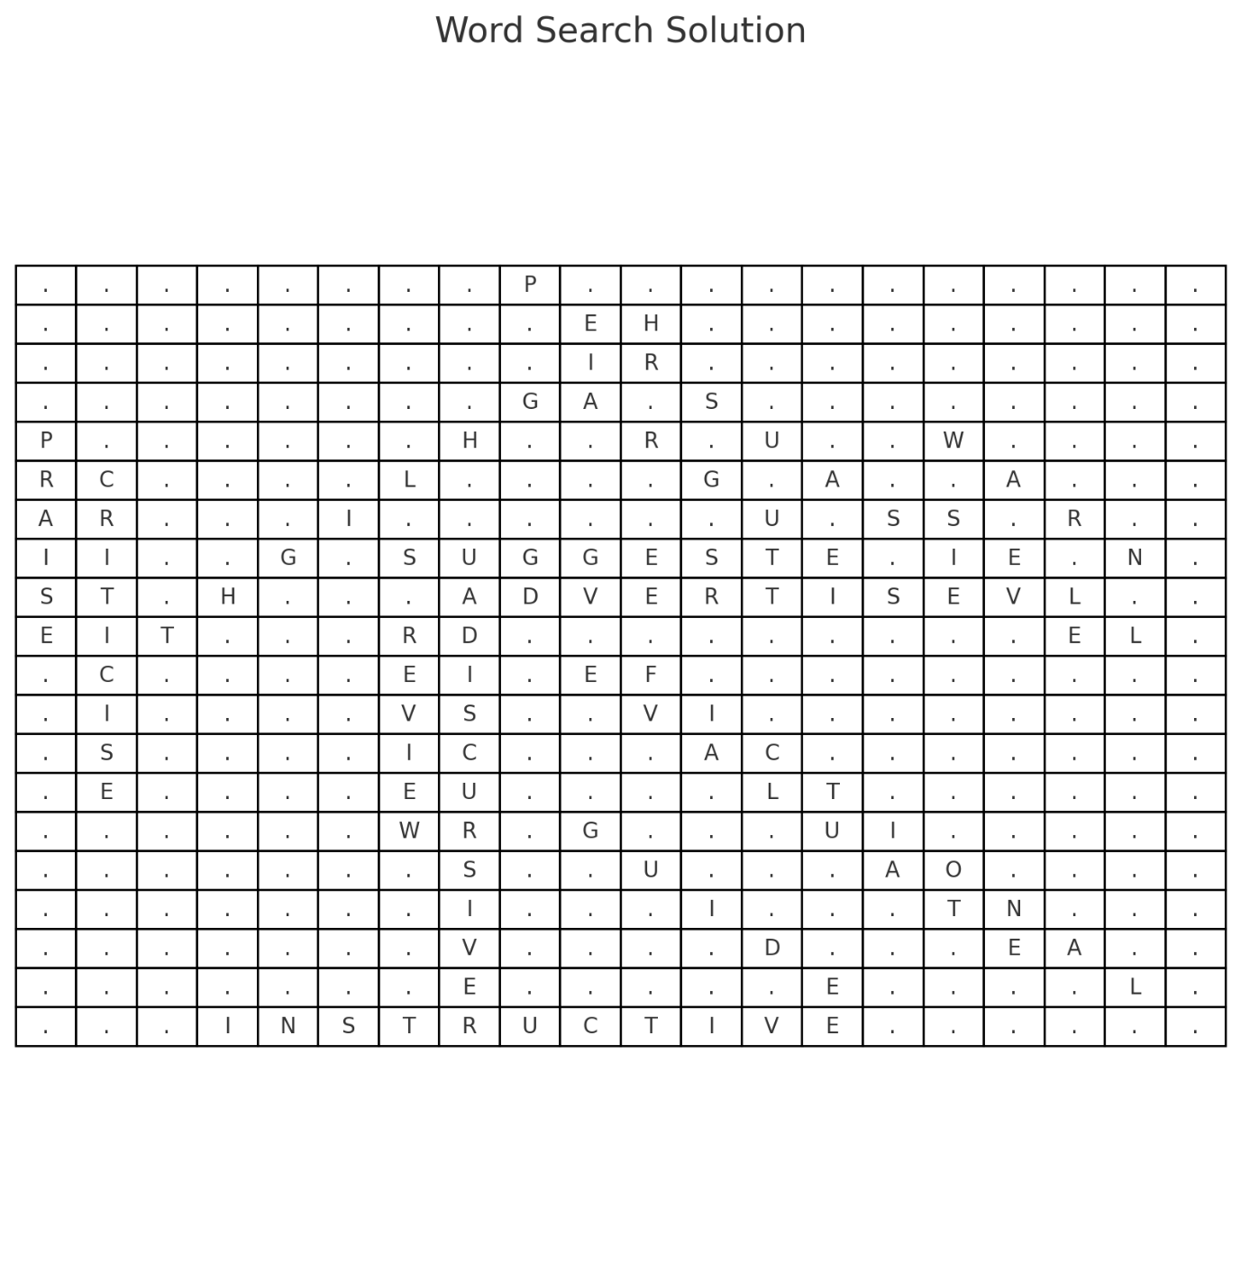

Answer key week 8
  - Which candidate has international experience? L L-B
  - Which candidate is up to date with student life in academia? VC
  - Which candidate has received recognition for success in business? CC
  - Which candidate seems not to have any professional experience yet? VC
  - Which candidate is known for having domestic experience? GJ
  - Which candidate can serve as mentor for a start-up company? AJ
  - Which candidate might be keen to ‘think globally but act locally’? LLB
  - Which candidate is most likely to be hired for sales and marketing? CC
  - Which candidate is most likely to be involved in social enterprise? LLB
  - Which candidate would be considered for an entry-level position? VC
  - Which candidate could be trusted with overseeing operations? AW
True or false:
  - Ashley can be described as meticulous in his work. T

  - Gethin will need to catch up on the recent changes in his industry. F

Answer key week 9
Text 1
1. What kind of text is it?
□ Email □ Review □ Blog □ Advertisement
- What is the text about?
A job advertisement for a carpenter

Text 2
- What kind of text is it?
□ Email □ Review □ Blog □ Advertisement
- What is the text about? - asking the manager/supervisor for a salary increase

Text 3
- What kind of text is it?
□ Email □ Review □ Blog □ Advertisement
- What is the text about? - a review of an online shopping website

Text on Sustainability – Answers
1. List three methods of sustainable transportation mentioned. (Any from – cycling/public transport/driving electric or hybrid cars or walking)

2. What are two ways to manage energy consumption sustainably? (using energy efficient appliances/installing solar panels/turning off lights)

3. How does diet affect sustainable living? (Locally sourced, organic food reduces the carbon footprint associated with transporting food over long distances. Reducing meat consumption can significantly decrease greenhouse gas emissions, as livestock farming is a major contributor to methane production).

4. What are three practices to reduce waste? (recycling, composting and reducing the use of single-use plastics)

5. Why is community involvement important in sustainable living? (taking part in community gardens, local clean-up events and sustainability workshops can foster a collective effort towards a more sustainable future)

Answer key week 10
1. Why is the narrator recording these events?
a. to ask other people for help in finding the treasure
b. to help him remember what happened a long time ago
c. to respond to a request from people he knows
d. to share important information about the treasure with other people

2. In the second paragraph, what is the meaning of the word ‘barrow’?
a. a particular area
b. a short time
c. a type of profession
d. a vehicle

3. What does ‘did so’ refer to in the second paragraph?
a. arriving at the inn
b. checking the surroundings
c. knocking on the door
d. whistling to himself

4. Why did the man decide to stay at this place?
a. He liked the staff.
b. It was cheap.
c. It was remote with few people.
d. The food was good.

5. Why did the man ask if anyone had seen other sailors?
a. He wanted to avoid sailors.
b. He disliked sailors in general.
c. He was lonely and wanted some company.
d. He wasn’t a real sailor himself.

6. How did the man feel about paying the narrator?
a. He always paid him on time.
b. He would change his mind.
c. He complained about paying him.
d. He never paid him.

Can you hear the lights? The Aurora Borealis
7. The sounds are caused by a release of electrical charge in these conditions. (G)
8. The lights were also said to produce sounds that humans could hear.(E)
9. Some researchers simply dismissed these claims as legends. (D)
10. The sounds appeared to be more frequent on mountaintops than in lower lying areas. (F)
11. I have to say that they are even more magnificent than I expected. (A)
12. Musicians in particular have tried to capture the magic of the aurora in their work. (B)
* Extra sentence - No wonder – native peoples say that the sound of the lights is their ancestors speaking. (C)

Special Sports – Answers
Which paragraph ...
13. suggests that players would like to develop the sport further? (B – take it to the Olympics)
14. expresses some sadness about the sport’s future? (C – number of players is decreasing)
15. states that the sport includes features of three different games? (A – badminton/table tennis/tennis)
16. explains the origins of two modern sports? (E – Stoolball developed into cricket and baseball)
17. describes a common sports facility provided for the use of local people? (E – a village green)
18. says that the sport’s most unusual feature is how it can be played? (D – singles/doubles/teams/racquet/gloves/bare hands/basket)
19. describes a sport that always includes a large number of players? (E- Teams of males and females/an activity for the whole village to enjoy)
20. describes how technology has led to a change in the sport’s popularity? (A – thanks to the internet…)

Answer Key Week 11
Welsh Music - Answers
Assessment Criterion 1.1 – Identify the main point of the text
c) The revival and importance of Welsh music

Assessment Criterion 1.2 – Identify the main events of the text
c) Eisteddfodau
c) Famous Welsh rock bands became popular

Assessment Criterion 1.3 – Use language features to identify meaning in text
b) Music is an important part of Welsh identity
b) Because it is a Welsh word unfamiliar to English readers

Assessment Criterion 1.4 – Identify the meaning of vocabulary in text
c) A return to popularity or renewed interest
b) Tradition and culture passed down

Assessment Criterion 3.1 – Obtain specific information from text
Green Man Festival and Festival Interceltique
Gwenno

Assessment Criterion 3.2 – Evaluate information from different sources
(Example answer – accept any well-reasoned response):
I agree more with Source A because the text shows that Welsh music festivals and songs in the Welsh language help keep the culture and language alive. Music can make people more interested in learning and using the language.

Answer Key Week 12
British Food - Answers
1.1 – Main Point
c) To show how British food has changed over time
1.2 – Main Events
b) Roast beef and Cornish pasties
c) More people are choosing plant-based diets
1.3 – Language Features
b) People are trying new types of food from different cultures
b) To suggest British food is now global and modern
1.4 – Vocabulary
b) The ability to grow and produce food in a way that does not harm the planet
c) Willing to try new or exciting things
3.1 – Specific Information
Indian, Chinese, Italian (also accept Middle Eastern)
Afternoon tea, full English breakfast, Christmas dinner

Answer key Week 13
Britpop Text - Answers
1.1 – Main Point
- c) The rise and influence of Britpop in the 1990s
1.2 – Main Events
- c) Blur and Oasis released singles on the same day
- b) It was replaced by new music styles
1.3 – Language Features
- c) They competed with each other
- c) It highlights that Britpop was a special and successful time in music
1.4 – Vocabulary
- c) Positive and energetic
- b) Changed or affected something
3.1 – Specific Information
- Oasis and Blur (also accept Pulp, Suede, or Elastica)
- Country House

Answer Key week 14
British Festivals - Answers
1.1 – Main Point
- c) To inform readers about unusual British celebrations
1.2 – Main Events
- b) Snorkels, flippers, and fancy dress
- c) People carry burning barrels through the town
1.3 – Language Features
- b) They care about tradition and each other
- c) To limit who can take part
1.4 – Vocabulary
- b) Strange in an interesting or fun way
- c) People who take part in the event
3.1 – Specific Information
- 60 yards
- A wheel of cheese

Answer key Week 15
Tiger Bay - Answers
1.1 – Main Point
- c) To tell the story of Tiger Bay and its multicultural community
1.2 – Main Events
- b) They came to work in Cardiff’s coal-exporting docks
- b) Many buildings were destroyed and the community was changed
1.3 – Language Features
- b) It was a lively and vibrant place to live
- c) It highlights pride in the community’s history
1.4 – Vocabulary
- b) A place with people from many different cultures
- c) Building new homes and shops
3.1 – Specific Information
- Jazz
- Shirley Bassey

Answer Key Week 16
Coronation Street - Sample Answers
1.
User2 (CorrieCritic2025) – says the writing has become lazy and focused on shock value.
User4 (OldSchoolCorrie) – says the show no longer has warmth and heart; it’s too serious or dramatic now.
2.
User3 (NewbieWatcher) – likes the fast pace and drama; doesn’t mind if it’s unrealistic because it’s entertaining.
3.
User4 – values the warmth and humour of past episodes and misses the atmosphere of everyday scenes like the corner shop.
4.
User5 (MediaTeacherAlex) – speaks from a media studies viewpoint. They analyse the show’s strategy to survive in a modern entertainment market, unlike the personal opinions of the others.
5.
Both User1 and User2 have watched the show for years.
They agree that the show has changed.
User1 still enjoys it and thinks it tackles important issues well.
User2 thinks it has lost its quality and become too dramatic.
6.
User3 – is a new, younger viewer who started during lockdown and finds the newer characters relatable and the drama exciting.
7.
The show seems to be more popular with newer viewers, like User3, who enjoy the faster pace and diversity.
Older viewers like User2 and User4 miss the traditional style and feel disconnected from the modern version.

Answer Key Week 17
Garden Centres - Sample Answers
1. b) To describe why garden centres have become popular in the UK
2. Any three of:
– To relax in peaceful surroundings
– To eat at cafés/restaurants
– To browse and shop for gifts or home items
– To enjoy Christmas displays
– To meet with friends/family
- Visit Santa’s grotto, see decorations and lights
4. b) They feel relaxed and away from stress
5. a) People arrive in large numbers, like birds
6. b) Places for relaxing and enjoyment
7. a) Looking around without the intention to buy anything immediately
8. Homemade cakes, cream tea, Sunday roast
9. They have open space, often flat ground, and fewer crowds
10. Peaceful setting, good food, wide range of products, social space, accessible, festive activities
11. Too expensive, focus more on lifestyle than gardening
12. (Learner’s own response, but should include evidence from the text)

Answer Key Week 18
Merthyr Tydfil Text - Sample Answers
- c) To give a historical overview of Merthyr Tydfil
- Any three:
– Growth of the iron industry in the 1700s–1800s
– Trevithick’s locomotive in 1804
– Merthyr Rising in 1831
– Decline of iron and coal industries
– Recent investment in tourism
- Workers protested due to poor conditions and food prices; the army was sent in and Dic Penderyn was executed
4. b) It was full of heavy industry and pollution
5. c) The town is making positive changes
6. c) A new idea or invention
7. b) People without jobs
8. Richard Trevithick, at Penydarren
9. Cyfarthfa Castle Museum and BikePark Wales
10. Hardworking, industrial, proud, full of struggle and innovation
11. Improving, investing in tourism and education, hopeful for the future
12. (Learner’s own opinion, could mention resilience, importance of innovation, remembering history, etc.)

Answer Key Week 19
Instagram Text – Answers
- c) To present the advantages and disadvantages of Instagram
2. Self-expression, promoting a business, finding inspiration
3. Mental health issues, addiction, privacy concerns
4. c) There is always something new to look at
5. b) It’s made to encourage people to spend more time on it
6. b) Showing your personality or creativity
7. b) Someone who posts content and encourages others to buy or do things
8. 2010
9. Photo and video sharing, stories
10. Anxiety, poor sleep, pressure to look perfect
11. Self-expression, building businesses, getting inspiration, connecting with others
12. Mental health issues, addiction, cyberbullying, unrealistic expectations
13. (Learner’s own opinion – encourage use of evidence from the text)

